Real Estate Management System for Assetline Leasing PLC

# Introduction

The Real Estate Management System (RMS) is an end-end real estate management system from creating projects, budgeting to Sale of projects. The system comprises of several modules and has the capability to integrate with third party systems. The system also gives the user with necessary information for business decision making. This document describes the key features that will be delivered during system implementation.

Contents

1 Introduction 2

2 Scope 2

3 Out of scope 2

4 Modules 2

5 Customer care 2

5.1 Reservation 2

5.2 Reservation transfer 3

6 Projects 5

6.1 Creating New Projects 5

6.2 Budgeting 6

6.3 Budget Transfers?? 8

6.4 Other Income 8

6.5 Sale 9

6.6 Common Areas 10

7 Project Development 11

7.1 Block out 11

7.2 Block Demarcation 12

7.3 Block Pricing 13

7.4 Development bill 14

7.5 Cost Allocation 15

7.6 Confirm Sold Note Generation 16

8 Information 17

9 Reports 18

10 Admin Module 18

Figure 5‑1 Reservation UI 11

Figure 5‑2Transfer Reservation UI 12

Figure 5‑3: Reservation Cancellation UI 13

Figure 6‑1Create/Update Project 14

Figure 6‑2 Budgeting UI 15

Figure 6‑3 Budget Transfer UI 16

Figure 6‑4 Other Income UI 17

Figure 6‑5 Sale type creation UI 18

Figure 6‑6 Defining Non salable items 19

Figure 7‑1 Defining Block 20

Figure 7‑2 Plotting block Ids on survey plan 21

Figure 7‑3 Block Pricing UI 22

Figure 7‑4 Generating Development related bills 23

Figure 7‑5 Cost Allocation 24

Figure 7‑6 Generating confirm Sold Note 25

Figure 8‑1 Information Console 26

# Scope of Work

# Out of scope

# Modules

The Real Estate Management System (RMS) covers a several modules. Below are the key modules;

1. Customer care
2. Projects
3. Project Development
4. Information
5. Reports
6. Amin module

# Customer care

## Reservation

Reservation deals with the reservations of block pertaining to projects here the user can search available blocks and make necessary reservations. Information captured are shown below in the UI below (refer figure 5-1).

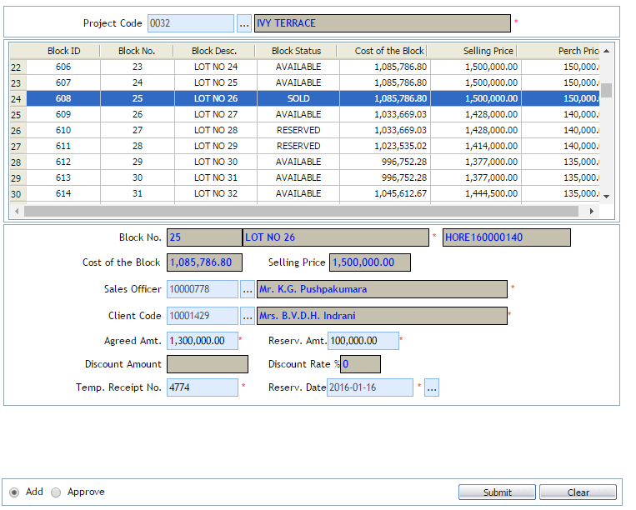

Figure ‑ Reservation UI

## Reservation transfer

If transfer of reservation is required, an authorized user will be able to select another available block and transfer the reservation from the initial block to the new block. In this case the old block will regain the ‘Available’ status and the new block will be converted to ‘Reserved’ status. The details captured and the UI for this is as per figure 5-2.

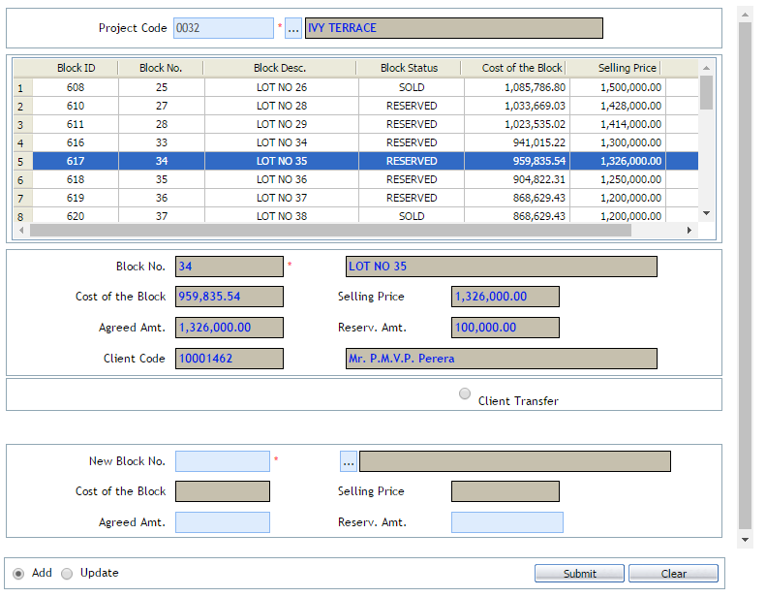

Figure ‑Transfer Reservation UI

## Cancel Reservation

An authorize user is given the feature of cancelling a reservation. The user is able to update the cancellation with a refund amount (if required) and proceed with the cancellation. The information captured and UI are as per figure 5-3. In this instance the system will revert the block status back to ‘Available’. However, the refund amount will get update in the system as an income.

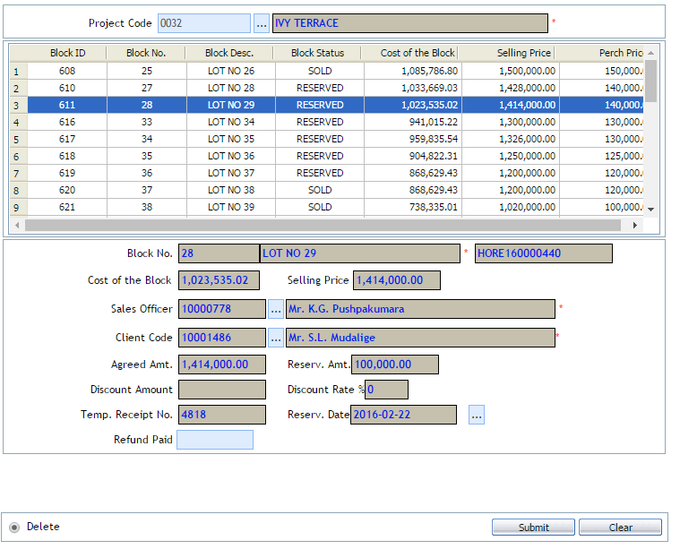

Figure ‑: Reservation Cancellation UI

# Projects

Projects are the key component of the RMS system. An authorized user is able to create/update projects and update the projects with activities. All activities can carry a budgeted cost. The projects can be then sent for approval. When approved if an activity is Added, Deleted or Adjusted the project will be revised and sent back for approval.

## Creating New Projects

An authorized user can create/update a projects. The information captured and UI are as follows (refer figure 6-1):

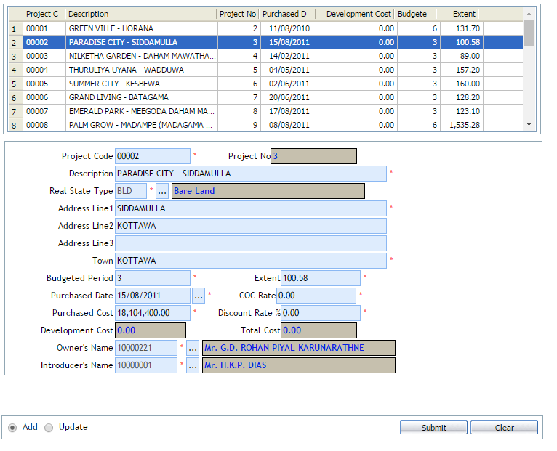

Figure ‑Create/Update Project

## Budgeting

An authorized user can assign predefined activities and cost types to a project and add a budgeted amount to the same. These can then be submitted for approval. Note activities and cost types can be defined through the admin console. Refer figure 6-2 for UI and information captured.

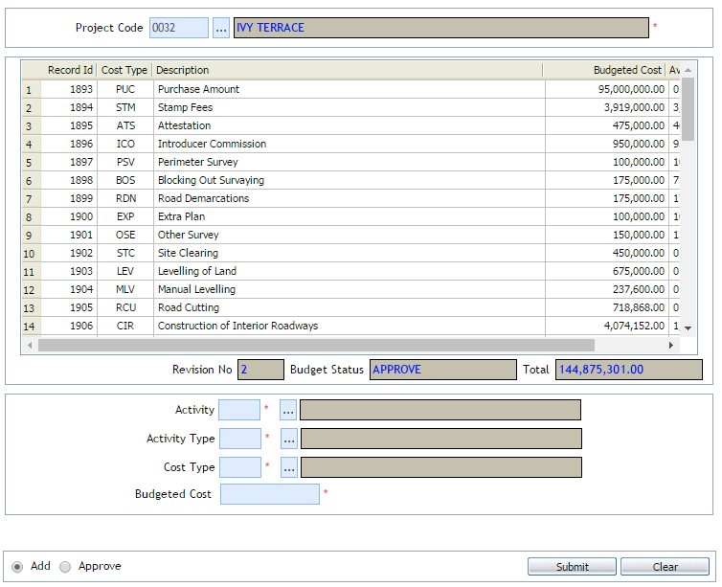Figure ‑ Budgeting UI

## Budget Transfers

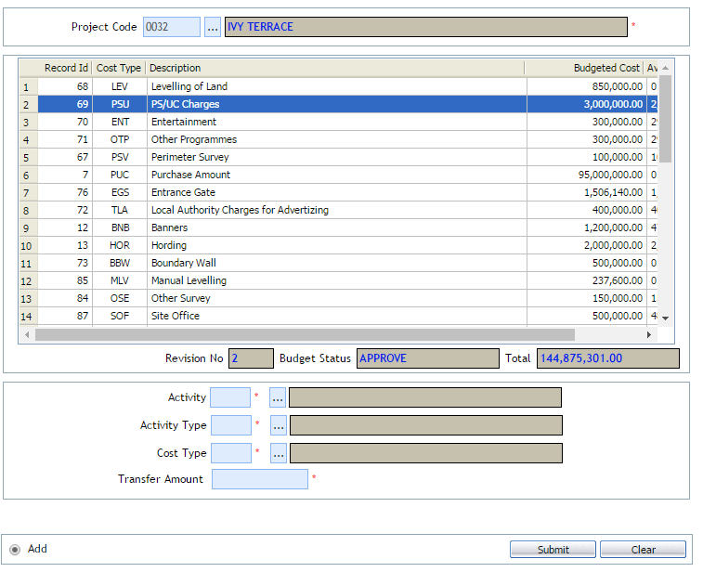

Figure ‑ Budget Transfer UI

## Other Income

An authorized user is able to add other miscellaneous income to a project budget. Refer UI 6-4

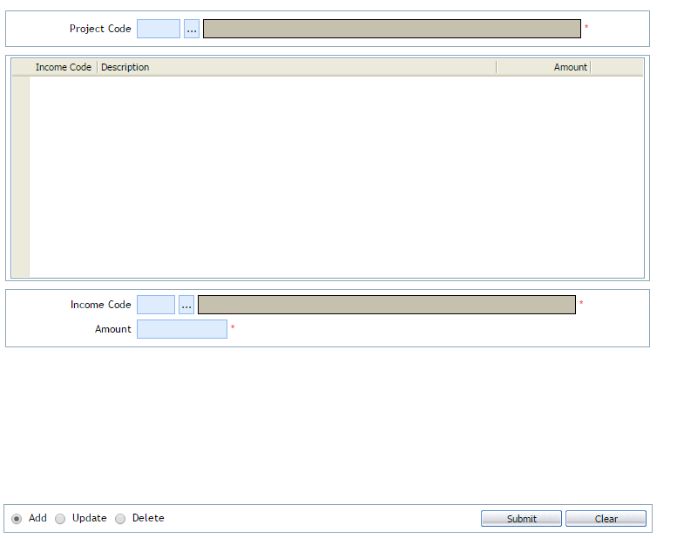

Figure ‑ Other Income UI

## Sale

Against each project an authorized user can define sales, based on the type of development. These types can be defined at an admin level. Refer figure 6-5 for information captured and UI.

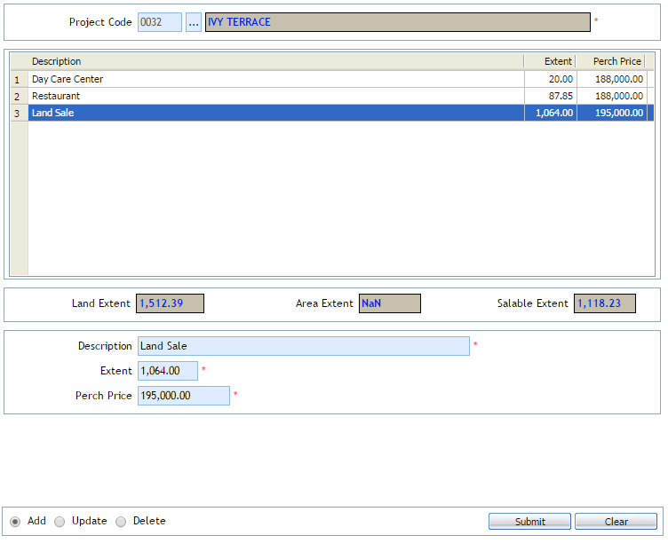

Figure ‑ Sale type creation UI

## Common Areas

Against each project an authorized user can define non salable items, based on the type of development. These types can be defined at an admin level. Refer figure 6-6 for information captured and UI

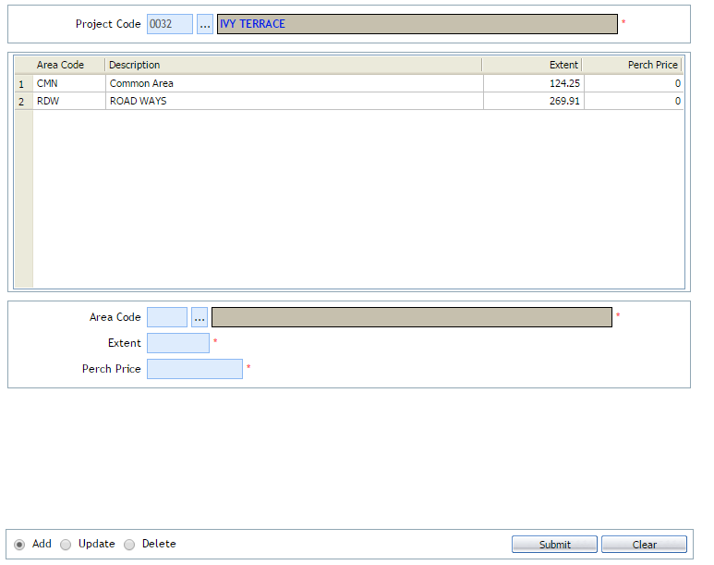Figure ‑ Defining Non salable items

# Project Development

## Block out

An authorized user is able to create/update blocks against a project. The user can create any number of blocks also the user can then attach block plans and mark the defined blocks on the attached plan. Refer figure 7-1 for information captured and UI.

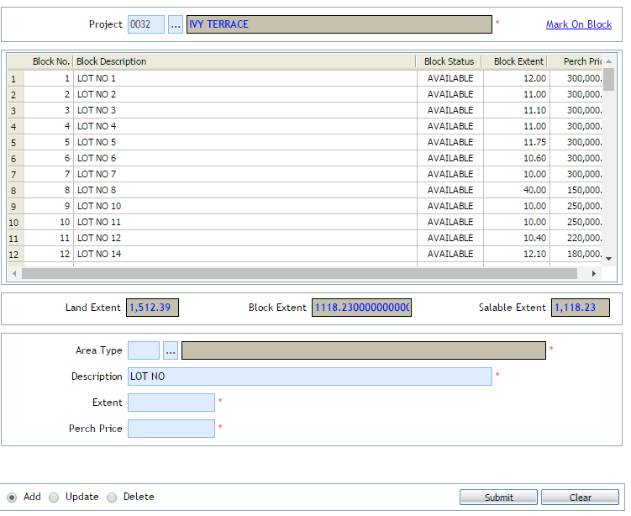

Figure ‑ Defining Block

## Block Demarcation

An authorized user can attach a survey plan in format 1, format 2 and Format 3. The user can subsequently plot according to block Ids and assign the predefined block Id against the plot. Refer figure 7-2 for information captured and UI.

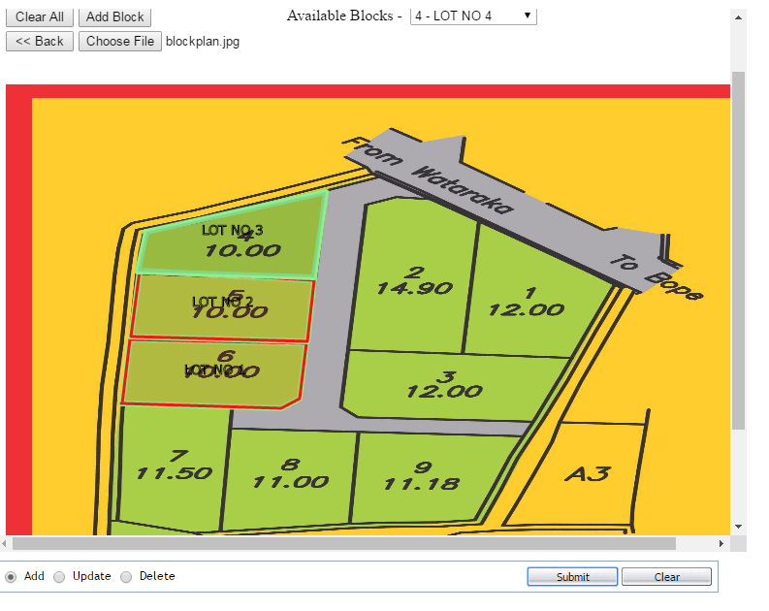Figure ‑ Plotting block Ids on survey plan

## Block Pricing

Blocks which are defined against a project will now be eligible for pricing. An authorized user is able to add block prices and send them for approval. An authorized user can approve the block pricing request. . Refer figure 7-3 for information captured and UI.

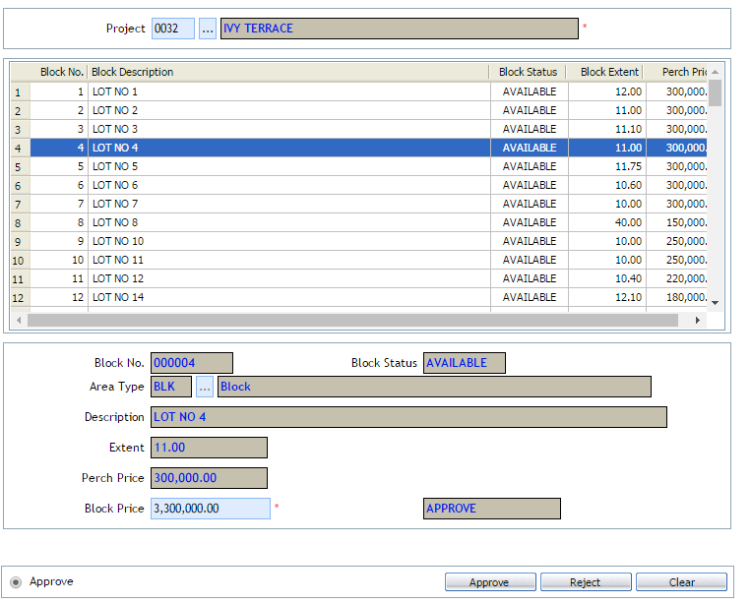

Figure ‑ Block Pricing UI

## Development bill

Bills can be development bills can be defined and generated through the system. All bills will be created against a defined budget and when generated the available budget shall be reduced. Refer figure 7-4 for information captured and UI.

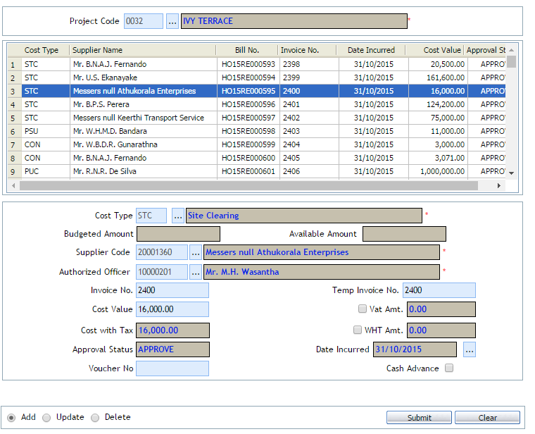Figure ‑ Generating Development related bills

## Cost Allocation

This area enables the user to view the budgeted cost vs the actuals against each project and generate reports of the same. Refer figure 7-5 for information available for this area.

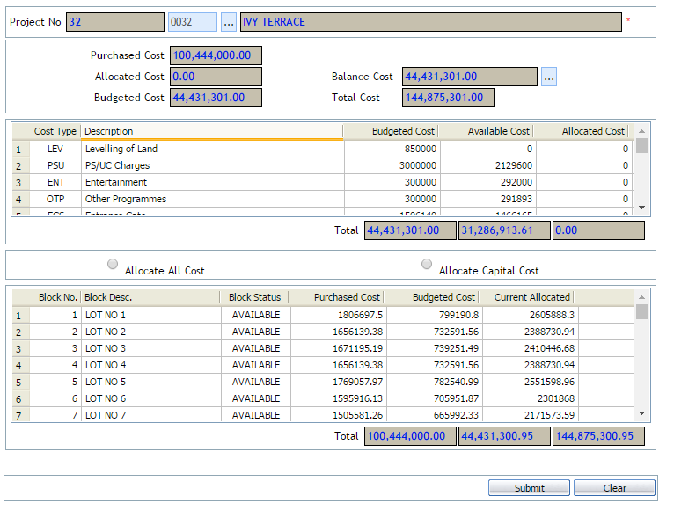

Figure ‑ Cost Allocation

## Confirm Sold Note Generation

The user can generate sold notes and send for approval, when approve the particular block status will be changed to ‘Sold’. An authorized approver can also reject the request stating reasons. Refer figure 7.6 for information captured and UI.

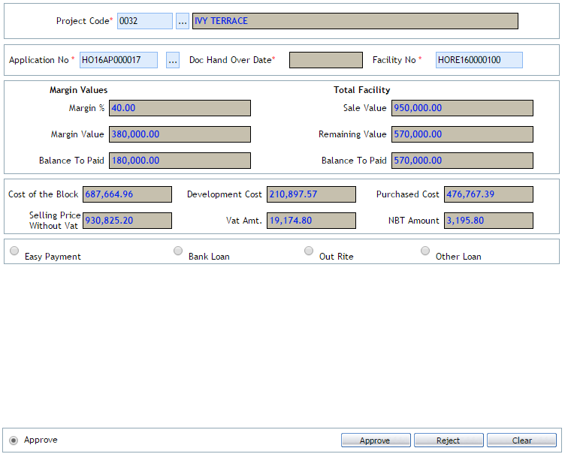Figure ‑ Generating confirm Sold Note

# Information

The system enables an authorized user to view information related to a project. This gives the user a ‘Birds Eye’ view of a selected project. The information provided is shown in figure 8-1.

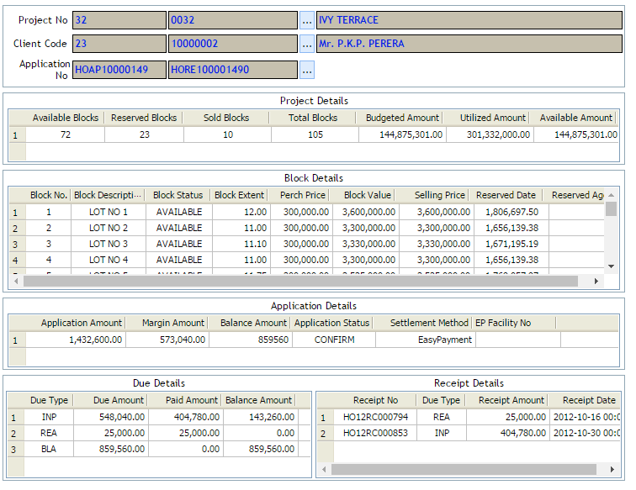Figure ‑ Information Console

# Reports

The proposed solution comprise of the following reports.

* + Current Project
  + Evaluation Report
  + Price List
  + Land Stock
  + Age Analysis
  + Client Statement

Refer annexure <> for sample reports

# Admin Module

An authorized admin user has the capability of defining master data in the system. The list of master data are as follows;

1. Activity
2. Activity type
3. Cost type
4. Parameters
5. Parameter values
6. Income type
7. Area type
8. Real estate type
9. Approval level
10. Project officers
11. Standard property
12. Approval groups